

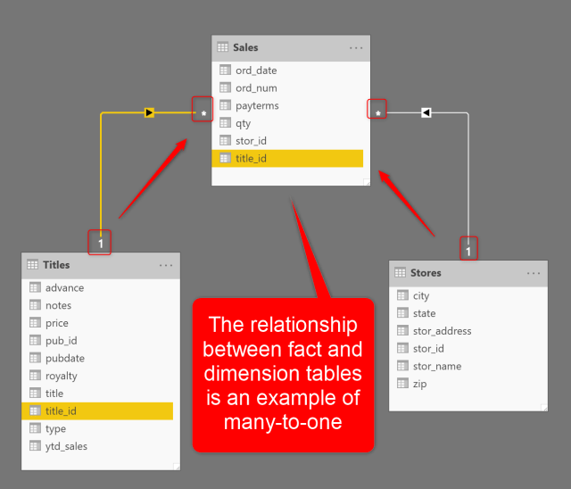

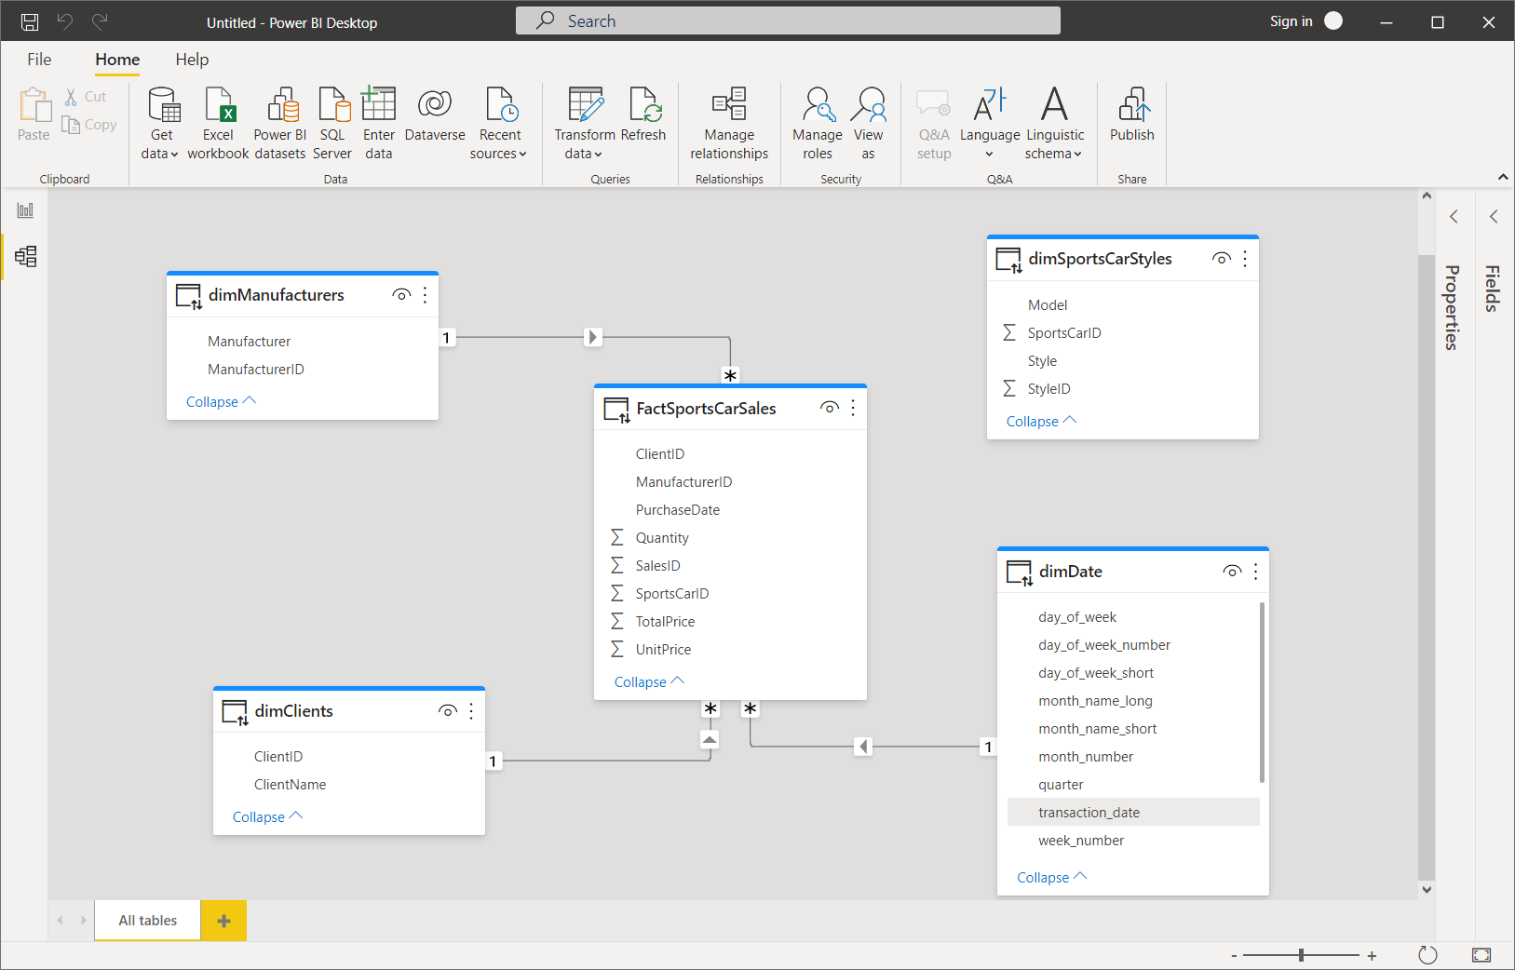

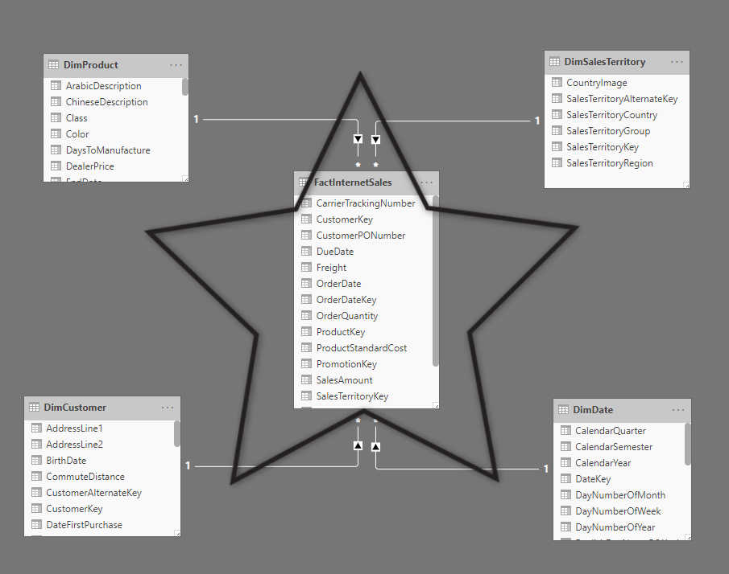

**1. Why Power BI Shows “Relationship Errors” (Root Causes)**

When Power BI fails to build relationships or shows warnings, **it is never random**. The errors always fall into **one or more of these categories**:

**A. Data Type Mismatch (Most Common Error)**

Power BI **cannot relate columns of different data types**.

| **Table A** | **Data Type** | **Table B** | **Data Type** | **Result** |
| --- | --- | --- | --- | --- |
| CustomerID | Whole Number | CustomerID | Text | ❌ Error |
| OrderDate | Date | OrderDate | DateTime | ⚠️ Weak / Wrong |
| ProductCode | Text | ProductCode | Text | ✅ Correct |

**Fix**

* Go to **Power Query → Change Data Type**
* Ensure **both columns are identical** (Text–Text, Whole–Whole, Date–Date)

**B. Duplicate Values on “One” Side**

Power BI requires:

* **One side → unique values**
* **Many side → duplicates allowed**

If both sides contain duplicates, Power BI cannot determine direction.

**Example**

* Customer table contains duplicate CustomerID
* Sales table also contains duplicate CustomerID

❌ Relationship fails

**Fix**

* Remove duplicates from **dimension tables**
* Use **DISTINCT**, **Remove Duplicates**, or build a proper dimension

**C. Cardinality Misinterpretation**

Power BI auto-detects relationships, but often detects them **incorrectly**.

| **Cardinality** | **Meaning** | **Real Use** |
| --- | --- | --- |
| One-to-Many | Best practice | Customers → Sales |
| Many-to-Many | Advanced | Student ↔ Courses |
| One-to-One | Rare | Employee ↔ Login |
| Many-to-One | Same as One-to-Many (reverse) |  |

**Rule**

Always force **One-to-Many** whenever possible.

**D. Ambiguous Relationships (Multiple Paths)**

Occurs when **two or more paths connect the same tables**.

**Example**

* Sales → Date
* Sales → Shipping Date → Date

Power BI gets confused: *Which date should I use?*

❌ Ambiguity error

**Fix**

* Keep **one active relationship**
* Set others as **inactive**
* Use USERELATIONSHIP() in DAX when needed

**2. Correct Data Modeling Approach (Industry Standard)**

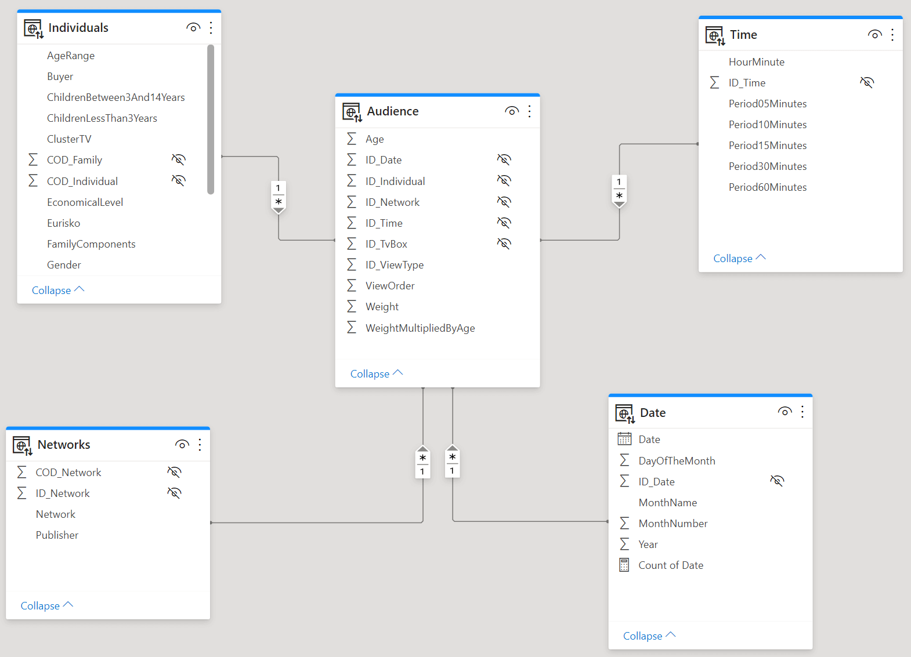

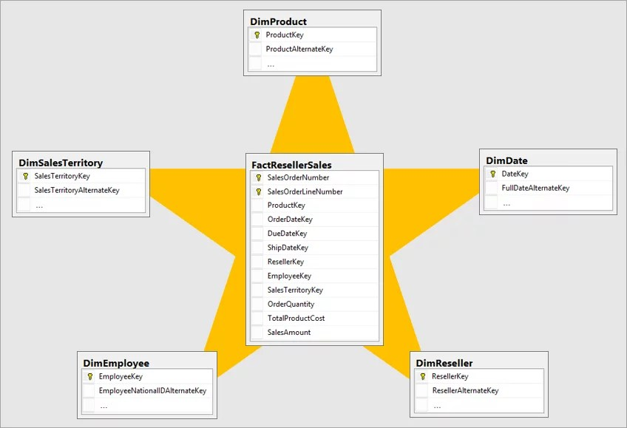

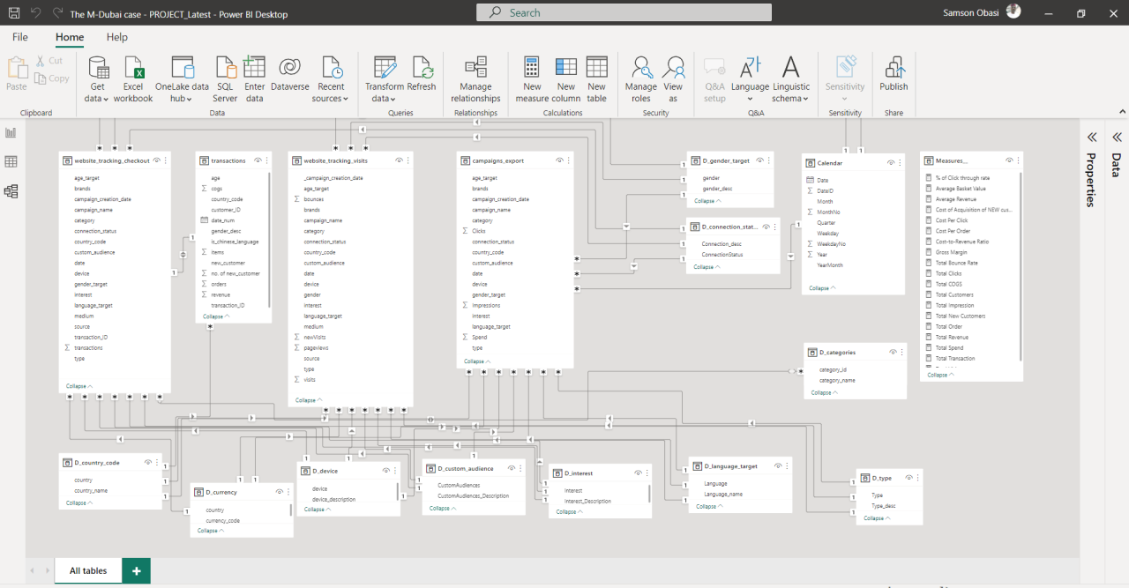

**Always Follow STAR SCHEMA**

**Dimension Tables (Lookup)**

* Customer
* Product
* Date
* Region
* Category

**Fact Tables (Transactions)**

* Sales
* Orders
* Payments
* Attendance
* Inventory

**Golden Rule**

Facts connect ONLY to Dimensions  
Dimensions never connect to Dimensions

**3. Relationship Building – Step-by-Step (Correct Method)**

**Step 1: Clean Data in Power Query**

* Remove blanks
* Remove duplicates from dimension keys
* Fix data types
* Trim spaces (Text Columns)

**Step 2: Define Keys Explicitly**

Examples:

* CustomerID
* ProductID
* DateKey (YYYYMMDD)

Avoid:

* Names
* Emails
* Phone numbers

**Step 3: Create Relationship Manually**

Go to **Model View → Manage Relationships → New**

Set:

* Cardinality: **One-to-Many**
* Cross Filter Direction: **Single**
* Active: ✔️

Avoid **Both** unless required.

**4. Power BI Context Explained (Critical Concept)**

Power BI works on **Filter Context + Row Context**.

**A. Filter Context**

When you select:

* A slicer
* A chart bar
* A filter

Power BI filters **dimension tables**, which then filter **fact tables via relationships**.

**B. Row Context**

Occurs in:

* Calculated columns
* Iterators (SUMX, AVERAGEX)

Row-by-row evaluation.

**5. Real-Life Business Examples (Very Important)**

**Example 1: Retail Sales Dashboard**

**Tables**

* Customers(CustomerID)
* Products(ProductID)
* Sales(CustomerID, ProductID, Amount)

**Relationship**

* Customers (1) → Sales (*)
* Products (1) → Sales (*)

**Context Behavior**

* Selecting *City = Nagpur* filters Customers
* Customers filters Sales automatically
* Total Sales updates correctly

**Example 2: College Attendance System**

**Tables**

* Students(StudentID)
* Subjects(SubjectID)
* Attendance(StudentID, SubjectID, Date)

**Problem**

* Many-to-Many between Students & Subjects

**Solution**

* Attendance becomes **Fact Table**
* Students & Subjects are **Dimensions**

Correct Model = Accurate attendance %

**Example 3: GST / Accounting System**

**Tables**

* PartyMaster(PartyID)
* InvoiceHeader(InvoiceID, PartyID)
* InvoiceDetails(InvoiceID, Amount)

**Relationships**

* Party → InvoiceHeader (1-M)
* InvoiceHeader → InvoiceDetails (1-M)

This avoids **duplicate amount calculations**.

**Example 4: HR Payroll System**

**Tables**

* Employee(EmployeeID)
* Salary(EmployeeID, Month, NetPay)

If EmployeeID is Text in one table and Number in another → ❌

Fix data types → relationship works → salary reports correct.

**6. Common Mistakes to Avoid (Exam + Industry)**

❌ Using Names as Keys  
❌ Many-to-Many unnecessarily  
❌ Both-direction filtering everywhere  
❌ Multiple fact-to-fact relationships  
❌ Ignoring inactive relationships  
❌ Auto-detect trusting blindly

**7. Checklist Before Creating Any Relationship**

✔ Same data type  
✔ Unique values on “one” side  
✔ No blanks  
✔ Proper cardinality  
✔ Star schema structure  
✔ Single direction filtering

**8. Final Professional Advice (From Analyst Perspective)**

**90% of Power BI errors come from bad data modeling, not DAX.**  
A clean model reduces DAX complexity by **50–70%**.

If you want next:

* **Real dataset + correct model (step-by-step)**
* **DAX examples using relationships**
* **Common interview questions on Power BI relationships**
* **PDF notes for teaching / training**

Tell me how you want to proceed.